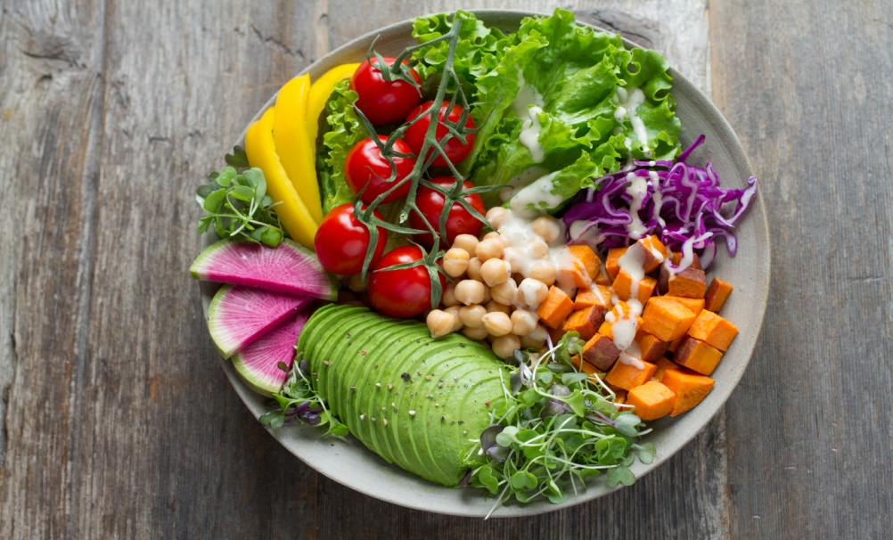

~​Intro. to Nutrtional Therapy.
Let food be thy medicine

Learn to eat real food again.
Learn what not to eat.
Discover what gives you energy.
Discover how to heal yourself with food.

Lara Aitken, 4 Winds Medicine
(407)654-8700
www.4windsmedicine.com

