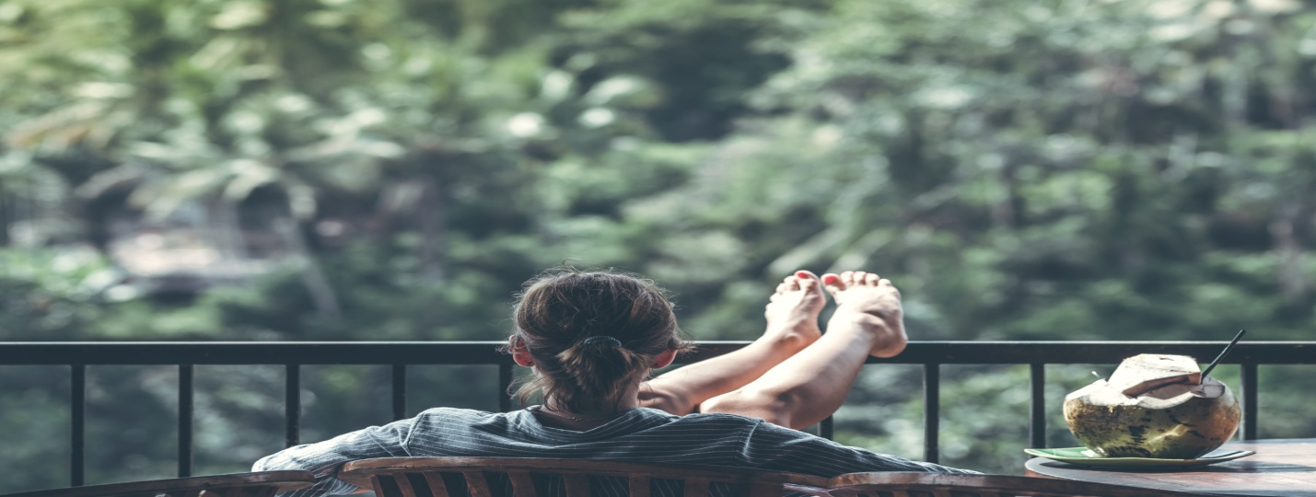
Manage Stress and Anxiety.

Learn to center yourself
Breathing techniques
Be mindful of your thoughts and activities.
Learn the best essential oils and foods to de-stress.

With the huge increase of stress, anxiety and depression in the past several years there has been an increased demand for help with anxiety. I have put together a class specifically for anxiety and depression. The class includes modalities such as self-massage, self-acupressure, meditation, yoga and breathing techniques, dietary, herbal, oil and supplement recommendations.

Please feel free to contact me with any questions.

Lara Aitken, 4 Winds Medicine
(407)654-8700
www.4windsmedicine.com

