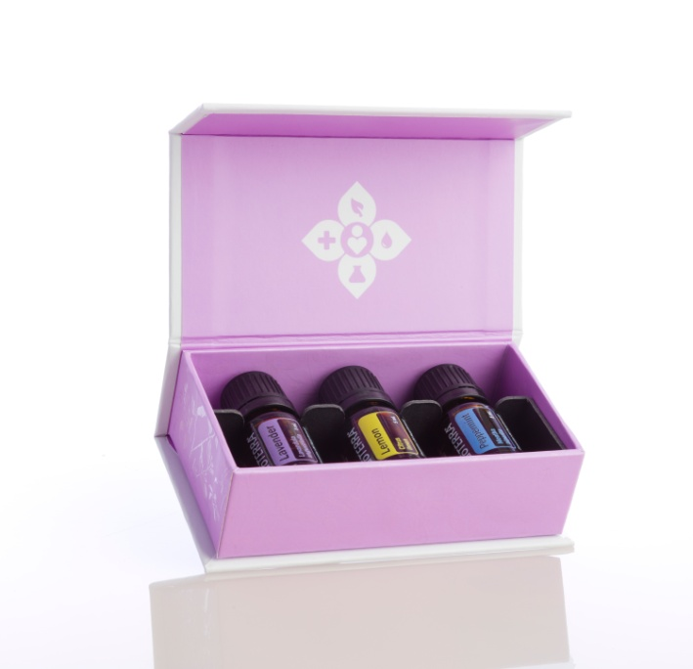

~How to use essential oils for health.

Learn to use oils for relaxation or energizing.

Which oils are best to use for cleaning.

What oils are best for baby.

Lara Aitken, 4 Winds Medicine
(407)654-8700
www.4windsmedicine.com

